Community Stand Scheme Report 2025-2026
The Mike Pusey Community Stand Scheme has gone from strength to strength again after another successful year during the 2025-2026 season. A total of 3,076 tickets were distributed across the year, an increase of 2.7% (2,995 tickets were distributed last season). This means an average of 134 tickets were given out per each home game (we can offer a max of 250).
We believe that if there was less postponments of Saturday 3pm kick offs then we would have distributed more tickets this season. As our main target of free tickets in the scheme is with the local community and in particular children, we tend to struggle to distribute many tickets for any midweek fixture. We gave tickets to 21 schools across the year, with 15 of those schools being ones we deliver after-school football clubs or CPD PE sessions to.
After removing concession tickets, 51% of tickets went to those under the age of 20. Most tickets that went to adults were for parents of children attending, some other adults who received tickets were part of community groups and organisations such as NHS workers at Christmas as part of our Shots Toy Appeal, and local charities such as Surrey Choices.
Youth beneficiaries included 41 grassroots football teams as well as various charities and community groups such as Surrey Choices, Vision 4 Youth and disadvantaged families. During the season, we reached out to the North East Hants Youth League to see if they could share the offer with their teams and we got an overwhelming amount of responses, so much so that we had to stop taking in applications. We are hoping to work with them again next season, which should see many grassroots clubs coming to see the Shots across the season.
Our most popular fixture was against Forest Green Rovers in which we managed to fill 245 of 250 seats. With this game being our designated rememberance day fixture, and from being in a military town, it is one of our most popular games of the season alongside the derby day fixture against Woking (which we do not distribute community tickets for).
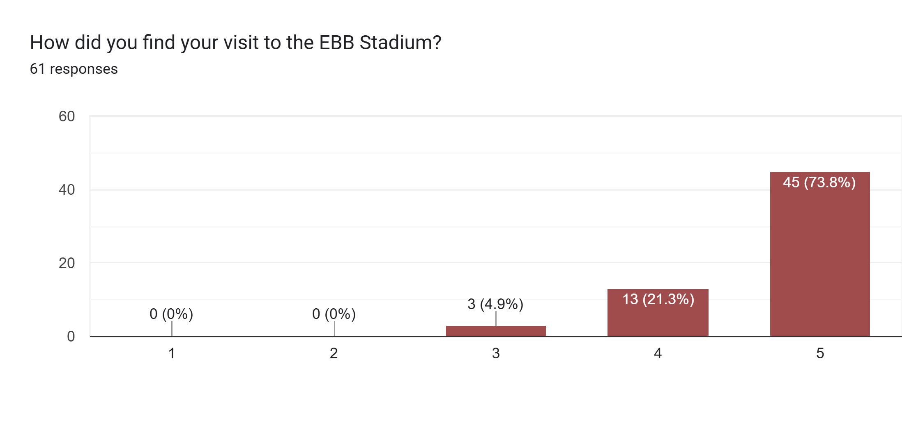
As you can see above, 74% of our responses stated that they had a very good visit to the EBB stadium with only 5% of responses stating that they had an average experience.
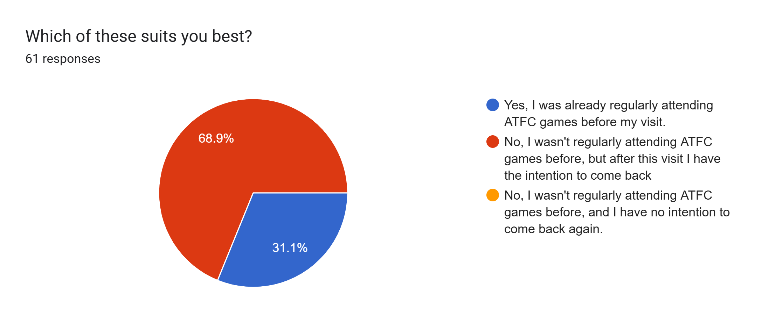
As shown above, we received 61 responses from our feedback form across the season with 69% of our responses stating that they hadn’t regularly attended a ATFC fixture and have the intention to attend again.
Having looked through fanbase deeper, of the 41 that said they intend to come back, 7 did. These people got tickets through the community stand scheme and then went and bought tickets for another home match during the season.

Testimonies:
- “Great atmosphere, friendly staff and club members, great afternoon out for our group.”
- “Thanks for thinking of the RFST when distributing the free tickets. It was nice to see the stand so full. I also found the communications prior to the tickets being issued very helpful and professional. All round much appreciated and rounded off nicely with a win.”
- “All the boys from Onslow FC enjoyed the experience and are asking to come back again. Some parents have even asked me how do they buy tickets as well as their boys wanting to come back more and watch the shots.”
- “As a serving officer of the British Army, I am really thankful for the tickets as a gesture of appreciation to the service we provide to the country.”

